ADC DENTAL SAVINGS PLAN APPLICATION

Name: ___________________________ DOB: ____________ Date: ___________

I understand this plan is in effect only if I am not covered by dental insurance ____ Initial

I understand this program is a discount plan, not dental insurance. __________ Initial

I am applying for:
_______ Individual $ 425
_______ Dual $ 830
_______ Family (3) $1185
_______ Family (4) $ 1560
_______ Family (each additional member) @ $410

TERMS AND CONDITIONS:

- Plan benefits
Diagnostic- 2 Routine Exams (Comprehensive or Periodic). Routine Xrays (Panoramic Xray or Bitewing Xrays)
Preventative – 2 Routine Cleaning (excludes periodontal services) Fluoride Treatment- 1 per year
Restorative, periodontal, endodontic, surgical and prosthetic services will receive 10% off of our office fees throughout the year. (Some services may be referred to a specialist and are not covered in the discount plan).

I understand and agree to the plan benefit terms: SIGN __________________________

- Plan conditions

- Member fee is non- refundable and non- transferrable
- No refunds or premiums will be issued at any time if participant decides not to utilize the plan.
- Total annual cost is due at the time of enrollment.
- Patient’s portion of bill is due at the time of service.
- Charges for missed, cancelled or broken appointments are excluded from the plan and must be paid prior to the next appointment.
- The plan participant is responsible for utilizing the plan’s services.
- This is a discount plan, not a dental insurance plan. It can not be used in conjunction with dental insurance or with any other dental plan.
- For treatment which, in the sole opinion of the treating dentist, lies outside the realm of their capability.
- For referral to a specialist.
- With any other offer or coupon.

I have ready and understand the plan conditions: SIGN ___________________________

You will not receive a membership card. The plan’s effective date will be on file with
the office.

Effective Date: ____________________

Plan will be active for 1 year after effective date.

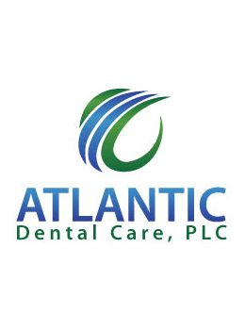 ADC DENTAL SAVINGS PLAN

You are eligible for the ADC Plan if:
- You are currently an active or a new patient of our practice.
- You do not have dental insurance.

Plan Benefits:
- You will receive 2 routine exams (Comprehensive or Periodic)
- Routine X-rays (Panoramic Film or Bitewings)
- Fluoride treatment 1 per year.
- 10% off services in office.
- No deductibles, monthly premiums or waiting periods.

With no dental coverage:
2- Exams $175
2 routine cleanings $228 Total: $679
X-rays $225
Fluoride $51

ADC dental savings plan:
2- Exams Included
2- Routine cleaning Included Total: $425
X-rays Included
Fluoride x 1 Included

